PRACTICAL – 9
Name: Teja Hasini Redddy
2520030048
Sec-8

PART 1: FILE COPY USING LINUX SYSTEM CALLS

Title
File Copy Using Low-Level Linux I/O and Performance Comparison

Aim
To implement a file copy utility using open(), read(), write(), lseek(), and close(), and compare its performance with fopen(), fread(), and fwrite().

Objectives
- To understand Linux file handling and file descriptors.
- To use low-level file I/O system calls.
- To copy data from one file to another.
- To compare system calls with standard library functions.

Theory
Linux provides system calls for file input and output. open() returns a file descriptor, read() reads data into a buffer, write() writes data to a file, lseek() changes the file position, and close() closes the file descriptor.
Standard library functions such as fopen(), fread(), fwrite(), and fclose() provide higher-level file handling.

System Calls / Functions
Function | Purpose
open() | Opens/creates a file
read() | Reads data
write() | Writes data
lseek() | Changes file position
close() | Closes file
fopen() | Opens file using library
fread() | Reads using library
fwrite() | Writes using library

Algorithm
- Start the program.
- Open the source file using open().
- Create the destination file using open().
- Read data using read().
- Write data using write().
- Repeat until the complete file is copied.
- Use lseek() to change the file position.
- Close both files using close().
- Repeat the process using fopen(), fread(), and fwrite().
- Compare their execution times.
- Stop.

C Program
#include <stdio.h>
#include <fcntl.h>
#include <unistd.h>

int main()
{
int source, destination;
char buffer[1024];
ssize_t bytes;

source = open("source.txt", O_RDONLY);

if (source == -1)
{
perror("Error opening source");
return 1;
}

destination = open("destination.txt",
O_WRONLY | O_CREAT | O_TRUNC, 0644);

if (destination == -1)
{
perror("Error opening destination");
close(source);
return 1;
}

while ((bytes = read(source, buffer, sizeof(buffer))) > 0)
write(destination, buffer, bytes);

lseek(source, 0, SEEK_SET);

close(source);
close(destination);

printf("File copied successfully.\n");

return 0;
}
OUTPUT -
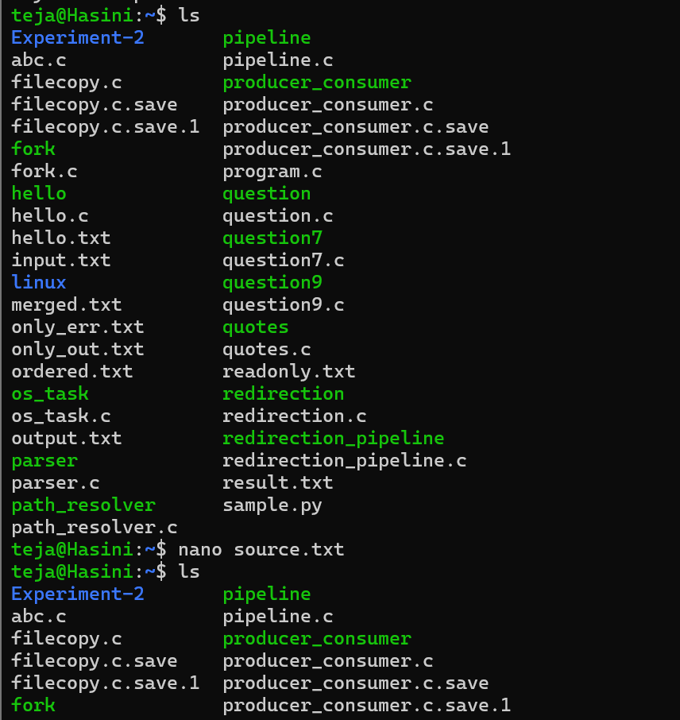

Performance Comparison
Use:
time ./lowlevel_copy
and:
time ./standard_copy
The actual execution time depends on file size, buffer size, storage device, and system load.

Flow Diagram
START
↓
Open Source File
↓
Create Destination
↓
Read Data
↓
Write Data
↓
More Data?
↓ ↓
YES NO
↓ ↓
Repeat lseek()
↓
close()
↓
STOP

Observation
The file was successfully copied using low-level system calls. The same operation can be performed using standard library functions, and their execution times can be compared.

Result
The file copy utility was successfully implemented using Linux system calls and its performance can be compared with standard library file operations.

PART 2: I/O REDIRECTION USING dup2()

Title
Standard Input and Output Redirection Using File Descriptors and dup2()

Aim
To develop a C program that redirects standard input and output using file descriptors and dup2(), demonstrating how shells implement I/O redirection.

Objectives
- To understand standard input and output.
- To understand file descriptors.
- To use dup2() for redirection.
- To redirect input from a file and output to another file.

Theory
Linux provides three standard file descriptors:
0 → Standard Input
1 → Standard Output
2 → Standard Error
The dup2() system call duplicates one file descriptor to another.
dup2(input_fd, STDIN_FILENO);
dup2(output_fd, STDOUT_FILENO);
After redirection, input comes from the input file and output is written to the output file.
For example:
cat < input.txt > output.txt
The shell opens both files and uses file descriptor duplication before executing the command.

Algorithm
- Start the program.
- Open input.txt.
- Open/create output.txt.
- Use dup2() to redirect standard input.
- Use dup2() to redirect standard output.
- Read data from standard input.
- Write data to standard output.
- Close the files.
- Stop.

C Program
#include <stdio.h>
#include <fcntl.h>
#include <unistd.h>

int main()
{
int input_fd, output_fd;
char buffer[1024];
ssize_t bytes;

input_fd = open("input.txt", O_RDONLY);

output_fd = open("output.txt",
O_WRONLY | O_CREAT | O_TRUNC, 0644);

if (input_fd == -1 || output_fd == -1)
{
perror("File error");
return 1;
}

dup2(input_fd, STDIN_FILENO);
dup2(output_fd, STDOUT_FILENO);

while ((bytes = read(STDIN_FILENO, buffer, sizeof(buffer))) > 0)
write(STDOUT_FILENO, buffer, bytes);

close(input_fd);
close(output_fd);

return 0;
}
OUTPUT -
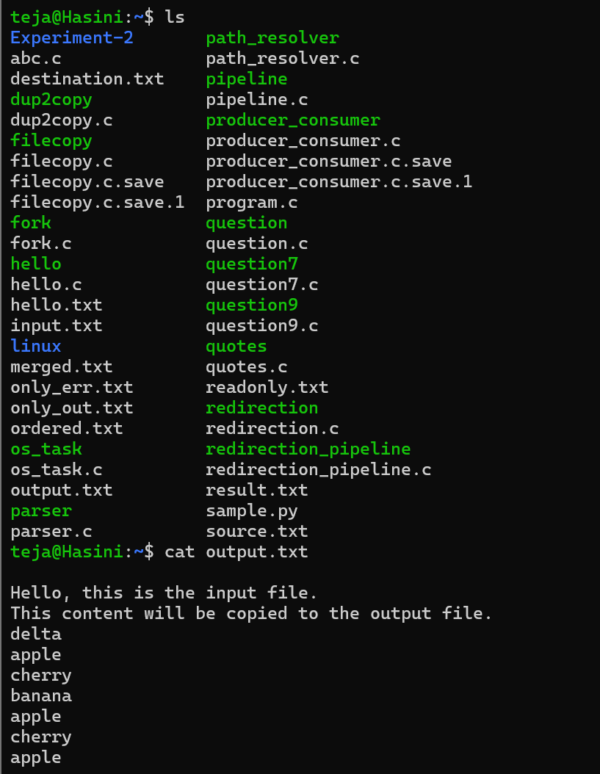
Compilation
gcc redirect.c -o redirect

Execution
./redirect
Check the output:
cat output.txt

Flow Diagram
START
↓
Open input.txt
↓
Open output.txt
↓
dup2(input, 0)
↓
dup2(output, 1)
↓
Read Input
↓
Write Output
↓
close()
↓
STOP

Observation
The input file was successfully connected to standard input and the output file was connected to standard output using dup2(). This demonstrates the basic mechanism used by shells for I/O redirection.

Result
Standard input and output were successfully redirected using dup2(), demonstrating how Linux shells implement file-based I/O redirection.

